Appendix D. Sensitivity analysis of cost-benefit parameters
D.1 Scope, perspective, and cost-accounting boundary
This appendix presents a partial cost-consequence analysis rather than a comprehensive cost-benefit analysis. Its unit of comparison is a simulated portfolio of 20,000 RMC batches. The inputs use relative cost units calibrated through practitioner interviews and conservative scenario assumptions. The analysis estimates direct operating resource costs and quality losses under alternative governance configurations. It cannot estimate observed lifecycle return on investment because field data on implementation and recurring administration are unavailable.
Three accounting views are distinguished. The consolidated resource-cost view includes verification, testing, rework, and remediation. It excludes premiums and claim payments because these items transfer funds between insured parties and insurers. The insured-project view records premiums as outflows and eligible claim payments as offsets to covered losses. The insurer view records premiums as inflows and claim payments as outflows. Insurer administration, risk capital, tax, and reinsurance remain outside the model.
Table D1 defines the model boundary. For each scenario, implementation-cost headroom is the reduction in consolidated resource cost relative to the conventional baseline. The headroom is a conditional decision screen. A positive project-level economic result would also require the omitted setup, integration, training, maintenance, and governance costs to remain below that headroom over the same evaluation horizon.
Table D1. Cost categories and accounting treatment
Cost category | Current treatment | Accounting view and interpretation
Conventional or Oracle verification | Included | Direct operating resource cost per batch
28-day testing | Included | Direct operating resource cost
Pre-delivery rework | Included | Direct quality-control resource cost, including rework following a flagged batch
Early and late remediation | Included | Direct resource loss; retained regardless of the party financing remediation
IDI premiums | Reported separately | Insured-project outflow and insurer inflow; excluded from consolidated resource cost
IDI claim payments | Reported separately | Insurer outflow and insured-project loss offset; excluded from consolidated resource cost
On-chain execution | Measured separately in Appendix C | Transaction-level comparison; not integrated into the project-level simulation total
System setup | Excluded | Network design, node deployment, chaincode configuration, onboarding, and incremental hardware
Data integration | Excluded | Interfaces to ERP, laboratory, sensor, and document systems; data mapping, cleaning, and migration
Stakeholder training | Excluded | Training delivery, procedural redesign, learning time, and transitional productivity loss
Platform maintenance | Excluded | Hosting, monitoring, cybersecurity, backup, upgrades, calibration, and technical support
Governance administration | Excluded | Membership and permission management, standards updates, audits, exception review, and dispute coordination
Consequential losses | Scenario-only stress test | Excluded from the direct-cost baseline; multipliers are assumptions rather than observed losses
Nonmonetized governance benefits | Not monetized | Traceability, accountability, and dispute evidence are evaluated separately
Discounting and insurer operating costs | Excluded | No project NPV, underwriting-profit, or actuarial-capital claim is made

D.2 One-way sensitivity of the framework's two value mechanisms
Fig. D1 reports one-way sensitivity for two distinct outcomes. In panel (a), Oracle resource-cost headroom relative to the conventional baseline is most sensitive to the baseline noncompliance rate, latent failure probability, late remediation cost, and Oracle true positive rate. Panel (b) shows that IDI dispute-rate reduction is most sensitive to Oracle detection capability, baseline noncompliance, latent failure probability, and dispute probability without insurance. The first outcome is an operating resource-cost measure, whereas the second is a nonmonetized governance outcome.
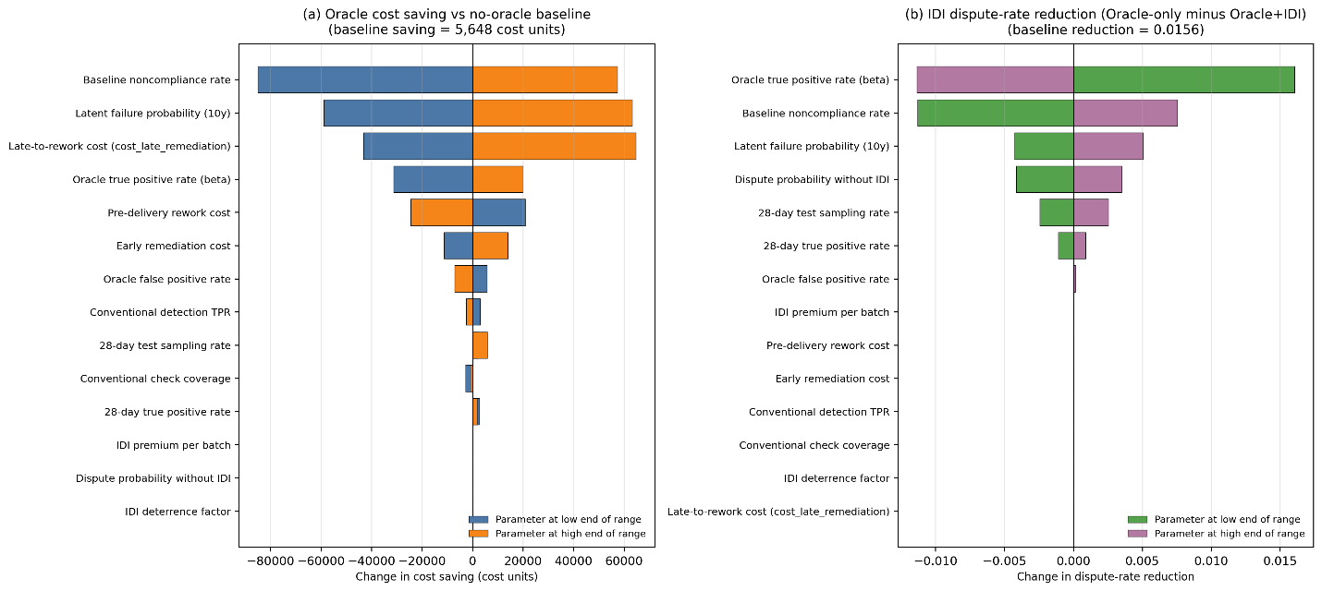Fig. D1. One-way sensitivity of oracle cost saving (panel a) and IDI dispute-rate reduction (panel b).
D.3 Oracle break-even thresholds as project-selection criteria
The break-even thresholds identify when Oracle-only resource-cost headroom becomes zero relative to the conventional baseline. They are scenario-screening values for the simulated portfolio rather than estimates of project-level return on investment. Table D2 reports the thresholds for the four most influential cost parameters identified in Fig. D1, together with the baseline values and corresponding adoption screens.
Table D2. Break-even thresholds and adoption criteria
Parameter | Baseline | Break-even | Adoption criterion
Baseline noncompliance rate | 0.20 | 0.193 | Adoption economically justified for projects with structural noncompliance risk above approximately 19 percent
Oracle true positive rate | 0.80 | 0.782 | Oracle technology must achieve detection capability above 78 percent
Late remediation cost (relative units) | 120 | 118.9 | Projects in which late-stage failure cost exceeds approximately 6.6 times the pre-delivery rework cost
Latent failure probability (10 years) | 0.45 | 0.444 | High-stakes structural elements in which more than 45 percent of undetected noncompliance manifests within the defect liability period
D.4 Consequence-scaled analysis
The baseline value of 120 relative units represents direct late remediation. The consequence-scaled analysis applies hypothetical multipliers to represent wider resource consequences, including emergency response, third-party damage, project disruption, and regulatory remediation. Insurance claim payments remain financial transfers and are not treated as resource costs. The multipliers are stress-test assumptions rather than observed project costs.
We varied the late-stage failure cost from 120 to 2,400 while holding other parameters constant. Fig. D2 reports implementation-cost headroom, defined as the reduction in consolidated resource cost relative to Baseline, for Oracle-only and Oracle+IDI.
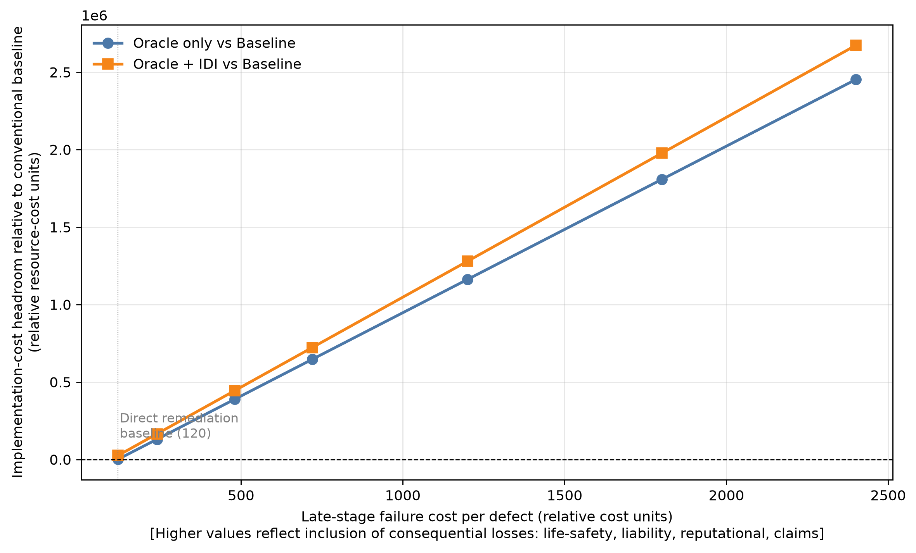
Fig. D2. Implementation-cost headroom under consequence-scaled late-failure costs.
Both configurations produced positive resource-cost headroom across the tested range. At the direct-remediation baseline of 120, headroom was 1,150.0 for Oracle-only and 25,705.5 for Oracle+IDI. At the ten-times stress-test value of 1,200, the values increased to 1,162,150.0 and 1,279,585.5, respectively. These amounts indicate the maximum omitted implementation and governance costs that the modeled operating saving could absorb over the same evaluation horizon.
Three bounded interpretations follow. Oracle headroom increases with the assumed consequence of late quality failure. The modeled IDI deterrence channel provides an additional resource effect by reducing opportunistic behavior. Premiums and claim payments do not alter consolidated resource cost; their stakeholder-specific effects are examined in Section D.5.
The values in Table D2 and Fig. D2 are scenario-screening criteria rather than evidence of project-level return on investment. Economic advantage requires site-specific setup, integration, training, maintenance, and governance costs to remain below the reported headroom. Field pilots are required to measure these omitted costs and test the assumed consequence multipliers.
D.5 Robustness of IDI
The IDI analysis assumes that the project owner acts as the policyholder and authorizes insurer access to an agreed evidence set; the required data fields, source-assurance criteria, compliance-score variables, and review intervals are specified before the relevant coverage period; and participating suppliers, RMC producers, contractors, and testing organizations are contractually required to submit and endorse records for activities under their control. The compliance score is treated as a provisional underwriting reference. Coverage, premium, exclusions, deductibles, claim eligibility, and settlement remain subject to insurer review. The deterrence parameter represents the assumed behavioral response when verified performance produces credible contractual or insurance consequences. It should not be interpreted as an automatic effect of IDI purchase. Premiums and claim payments remain stakeholder cash flows, and the analysis does not establish actuarial sustainability or insurer profitability.
Legal ownership of records remains governed by applicable contracts and law. For coordination purposes, the framework distinguishes custody of source records, the duty to submit agreed compliance data, authorization to use shared evidence, and authority to endorse a transaction. Each organization retains custody of its full source records, while agreed compliance fields and cryptographic commitments are shared under role-based access. Submission creates an auditable evidentiary record, while liability is assessed through the linked lifecycle evidence, insurance policy, project contract, and regulatory procedure. Missing or delayed submissions receive a provisional status and may trigger additional verification or contractual consequences. These data-sharing arrangements and the resulting disclosure responses are operational assumptions that require field validation.
IDI sensitivity was evaluated in the consequence-scaled regime with late remediation set to 1,200 relative units. The premium was varied from 3 to 25 per batch, the late claim payment from 600 to 3,000, and behavioral deterrence from 0.05 to 0.50. These sweeps distinguish consolidated resource effects from stakeholder cash flows. Five outcomes were reported. Resource headroom compares Oracle+IDI with Baseline using consolidated resource cost. The marginal resource effect compares Oracle+IDI with Oracle-only. The insured-project cash-flow benefit includes premiums and claim-payment offsets. The insurer loss ratio divides claim payments by premiums. The insured-project break-even premium equalizes Oracle+IDI cash flow with Oracle-only resource cost.
Panel (a) shows that the insured-project cash-flow benefit declines from 315,485.5 at a premium of 3 to -124,514.5 at a premium of 25. At the calibrated premium of 9, the insurer loss ratio is 1.434, indicating that claim payments exceed premiums within the simplified model. Panel (b) shows that consolidated resource headroom remains 1,279,585.5 across the claim-payment sweep. Higher payments improve the insured-project position while increasing the insurer's net outflow.
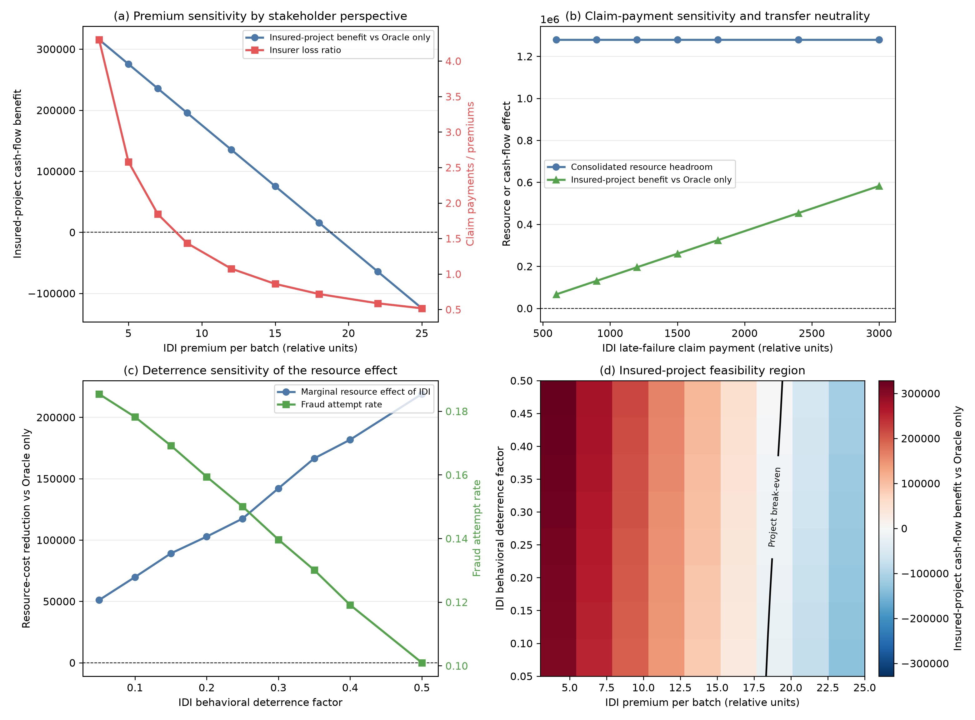
Fig. D3. IDI robustness under separated accounting perspectives. (a) Premium sensitivity of insured-project cash-flow benefit and insurer loss ratio. (b) Claim-payment sensitivity of consolidated resource headroom and insured-project benefit. (c) Deterrence sensitivity of the marginal resource effect and fraud-attempt rate. (d) Insured-project feasibility region across premium and deterrence; the zero contour marks project cash-flow break-even
Panel (c) isolates the modeled behavioral channel. As deterrence increases from 0.05 to 0.50, the marginal resource effect of IDI rises from 51,035.0 to 218,982.0, while the fraud-attempt rate falls from 0.1854 to 0.1010. Panel (d) maps insured-project cash-flow feasibility. Table D3 shows that the break-even premium rises from 18.3155 to 19.4216 across the deterrence range and equals 18.7743 at the baseline deterrence of 0.25. This frontier does not represent insurer profitability or consolidated resource cost.
Two implications follow. Premiums and claim payments redistribute financial exposure but do not change consolidated resource headroom. IDI produces a real resource effect only through the assumed deterrence channel. Project affordability and insurer sustainability must therefore be assessed separately. Because the default insurer loss ratio exceeds 1 and insurer operating costs, capital, and reinsurance are excluded, the analysis does not establish actuarial sustainability.
Table D3. Insured-project break-even premium by IDI deterrence factor
IDI behavioral deterrence factor | Insured-project break-even premium per batch
0.05 | 18.3155
0.10 | 18.4075
0.15 | 18.5259
0.20 | 18.6461
0.25 | 18.7743
0.30 | 18.9136
0.35 | 19.0376
0.40 | 19.1803
0.50 | 19.4216

